
A 10
SET NO : 1

Sreenidhi Institute of Science & Technology
(An Autonomous Institution)
Code No: 101MA04

B. TECH. I – Year II – Semester Examinations, Aug, 2011 (Regular)
MATHEMATICS - II for Bio-technology (BT)

Time: 3 Hours Max. Marks : 70

Note : No additional answer sheets will be provided.

Part-A (Objective Type)
Max.Marks:20

Answer all QUESTIONS.

1. Solve, (2x+e^{y}) dx + xe^{y} dy=0.

2. Solve x 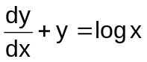.
3. Solve(D⁴+32D²+256)y=0, where D = 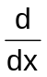.

4. Solve y|| - y = 0, y(0) = 0; y| (0) = 2.

5. Find the Laplace transform of the function f(t) = cos³ 2t.

6. Find 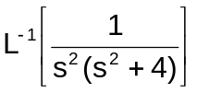.

7. Form the partial differential equation by eliminating arbitrary constants from 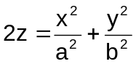.

8. If a function f(x) is even, its Fourier series is ______________________.

9. Find a unit normal vector to the surface xy²+2yz=8 at the point (3,-2,1)

10. If 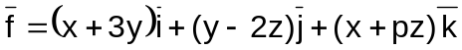is solenoidal, find "p".

Part – B
Max. Marks: 50

ANSWER ANY FIVE QUESTIONS.
EACH QUESTION CARRIES 10 MARKS.

1. a) Find the integrating factor and hence solve the differential equation.
(x³+y³+1) dx + xy² dy = 0. [ 5 ]

b) Find the orthogonal trajectory of the family of curves r = c (secθ+ tanθ) [ 5 ]

2. a) Solve (D² - 2D + 2)y = e^{x} + cosx, where 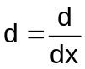. [ 5 ]
b) Solve (D² - 2D + 1)y = x² e^{3x} , where . [ 5 ]

3. a) Solve the partial differential equation x (y-z) p + y (z-x) q = z (x-y). [ 5 ]

b) Solve the partial differential equation 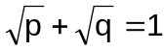. [ 5 ]

4. Find the Fourier series to represent the function f(x) = 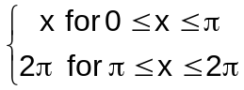and deduce that 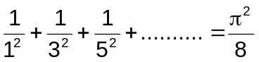 . [ 10 ]

5. a) Solve y|| + 2 y| - 3y =3; y(0) = 4 ; y| (0) = 7, using Laplace transform. [ 6 ]

b) Find the convolution e^{at} ∗ e^{bt}, (a≠b). [ 4 ]

6. Find the directional derivative of the function f(x,y,z) = 2x²+y²+z² at (1,2,3) in the direction of the line 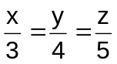. [ 5 ]

7. Verify Green's theorem for 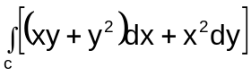, where "C" is bounded by y= x and y = x². [ 10 ]

8. a) Solve p²+q² = 2. [ 7 ]
b) Solve z=px+qy+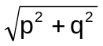. [ 3 ]

-- 00 -- 00 --

